Eileen Murphy: Fading Edens
November 16—December 30, 2022

at DFN Projects, 16 East 79th Street, Suite G-2, New York, NY 10075
Monday-Friday, 11am-4pm

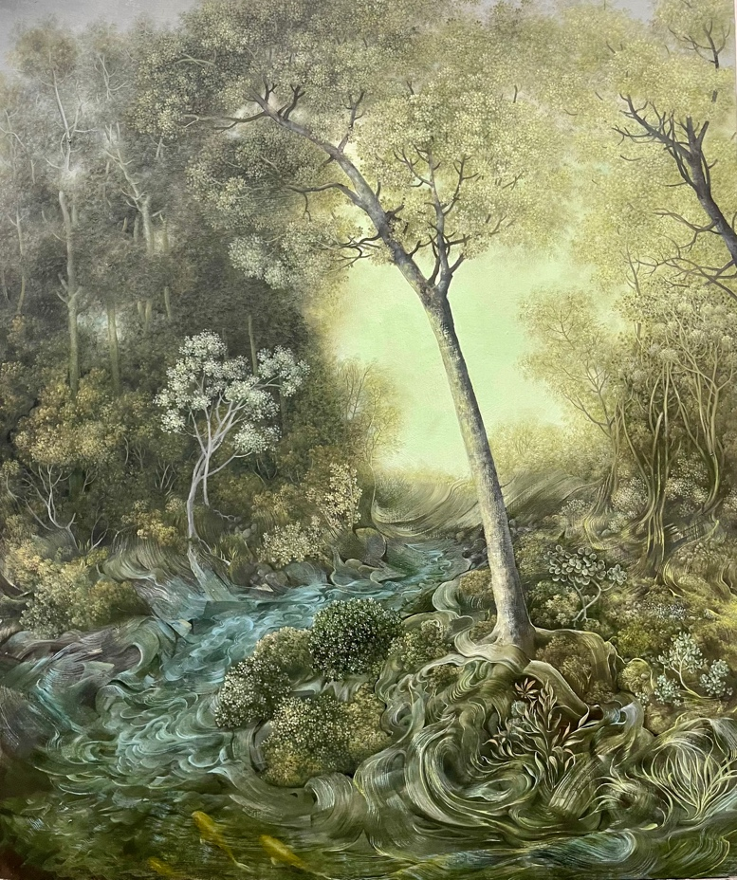
Eileen Murphy, In the Ponds Broken Off From the Sky My Feeling Sinks, 2022, oil on panel, 24 x 18 in.

(Upper East Side, New York, NY) Garvey|Simon is pleased to present Eileen Murphy: Fading Edens, opening November 16th at DFN Projects, 16 E 79th Street, New York, NY 10075. Fading Edens features a selection of recent landscape paintings on panel and on paper from Eileen Murphy; the latter of which is a relatively new medium for the artist. Murphy weaves together gossamer fantasies with Old Master details and allusions, conjuring up visions that simmer with memory. Eileen Murphy: Fading Edens is on view November 16 through December 30, 2022; a reception will take place on November 17th from 5-7pm. The artist will be present.

Eileen Murphy’s paintings on panels are a mirage of disparate memories. Lived experience, borrowed art historical footnotes, and imagery drawn from literary references swirl together and coalesce into shimmering sylvan scenes. Allusions to Patinir, Jacob von Ruisdael, Frederick Church, lines pulled from Rilke, and Murphy’s own personal history emerge deftly from the same brushstroke. The result is images that are simultaneously foreign and familiar, deeply intimate yet shared in a common vernacular. Murphy builds these compositions from layers of carefully applied oil paint, her brushstrokes growing increasingly specific and nuanced with each new stratum. Because she works on panel, the pigment is not absorbed into the material, but rather, sits atop the surface, the color remaining fully saturated. Without this anchoring effect, Murphy’s landscapes become lofty and voluminous, further intensifying their surrealist quality.

Unlike Murphy’s carefully arranged paintings on panel, with their premeditated visual syntax, her paintings on paper seem to happen into fruition. In this body of work she has inverted her making process, beginning with abstract gestures and textures and finding her way to a composition. As a result, these works are imbued with a searching quality - the desire to peer, forage, and unearth is implicit in the making process of the painting itself. This method of locating structure creates a subterfuge in the center of Murphy’s paintings; whether a deluge of rolling, leafy tendrils or a luminous expanse of negative space, there is a sense that these paintings have found their way to the center of the pictorial plane: exactly where they need to be. Though her works on paper are markedly more abstract than her paintings on panel, they assert themselves into the art historical narrative, evoking icons on Renaissance masters.

ABOUT THE ARTIST

Eileen Murphy has spent her life along the Hudson River and has lived in Brooklyn, NY for the last seventeen years. Her current paintings are based on the landscape of Columbia County, NY, where she and her dog Frito spend part of their time. Eileen has shown widely and has attended residencies to the Vermont Studio Center, Yaddo, and the High Line 9. She received the Individual Artist Award from the Santo Foundation in 2017; in that same year, she was invited by the US Department of State to participate in the Art in the Embassies program, which brought her to Algeria. She is currently the Lead Faculty in Drawing, Painting, and Printmaking in the MFA program at the Institute of Art and Design at New England College. Her most recent solo show in New York City was at Sears Peyton Gallery in Chelsea in January 2022.

For sales inquiries and viewing appointments, please contact Elizabeth Garvey at liz@garveysimon.com or 917-796-2146.

