PRICE LIST: Karl Hartman

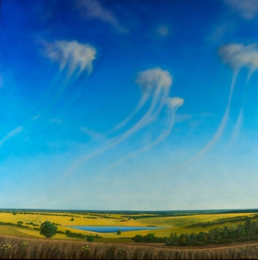 | Karl Hartman  Virga, 2014-2025  signed lower right  Oil on panel  36 x 36 in.  (38 x 38 in. framed)  (KHA029) | $ 6,000
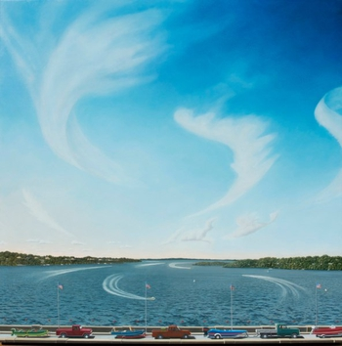 | Karl Hartman b. 9/8/1956  Fourth of July, 2017  Oil on canvas over board  34.0h x 34.0w in  86.36h x 86.36w cm  (KHA002) | $ 5,800
 | Karl Hartman b. 9/8/1956  Dust, 2012  Oil on panel  18.0h x 31.0w in  45.72h x 78.74w cm  (KHA023) | $ 4,800
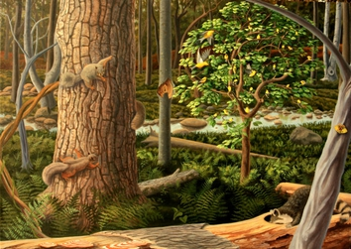 | Karl Hartman b. 9/8/1956  Charm of Finches, 2022  signed lower right "Karl Hartman"  Oil on aluminum panel  17.0h x 24.0w in  43.18h x 60.96w cm  (KHA031) | $ 4,800
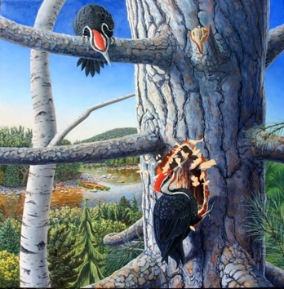 | Karl Hartman  Homesteaders, 2024  oil on aluminum  20 x 20 in  (KHA039) | $ 4,800
 | Karl Hartman American, b. 1956  Sun Halo, 2025  signed on back  oil on aluminum panel  28.25 x 22 in.  (KHA044) | $ 4,800
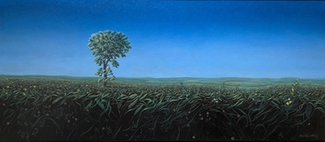 | Karl Hartman  Lone Cottonwood, c. 1999  signed lower right: Karl Hartman  oil on canvas mounted to panel  14.5 x 32.5 in.  (KHA048) | $ 4,600
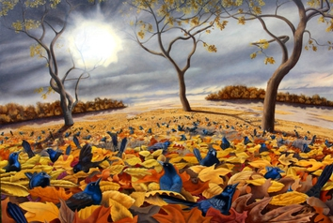 | Karl Hartman b. 9/8/1956  Black Birds in Leaves, 2024  oil on aluminum  17.0h x 24.0w in  41.91h x 60.96w cm  (KHA036) | $ 4,500
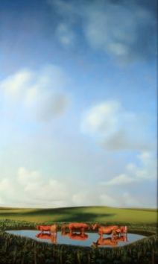 | Karl Hartman American, b. 1956  Reflections of Cows, 2008  signed on back  oil on wood panel  26 x 16 in.  (KHA045) | $ 4,500
 | Karl Hartman b. 9/8/1956  Compass Flower on the Cimarron River, 2020  Oil on aluminum panel  30.0h x 20.0w in  76.2h x 50.8w cm  (KHA019) | $ 4,400
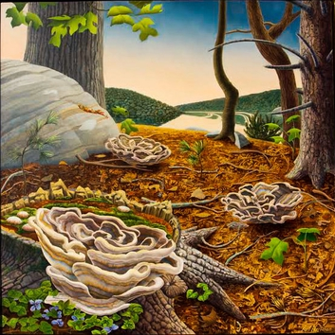 | Karl Hartman  Stump Blossoms, 2023  oil on aluminum panel  18 x 18 inches  (KHA037) | $ 3,300
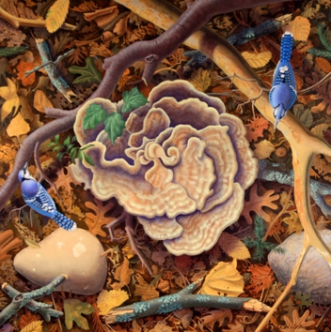 | Karl Hartman b. 9/8/1956  Blue Jays and Stump Blossom, 2024  signed on back  oil on panel  16 x 16 in.  (KHA040) | $ 2,500
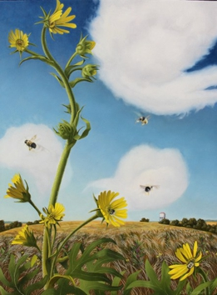 | Karl Hartman b. 9/8/1956  Bees and Compass Flower, 2019  Oil on panel  16.0h x 12.0w in  40.64h x 30.48w cm  (KHA017) | $ 2,200
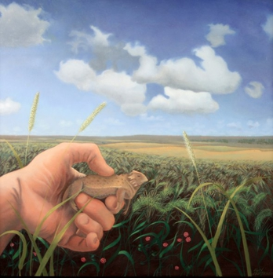 | Karl Hartman American, b. 1956  Horny Toad, 2023  signed on back  oil on panel  14 x 14 in.  (KHA046) | $ 2,200
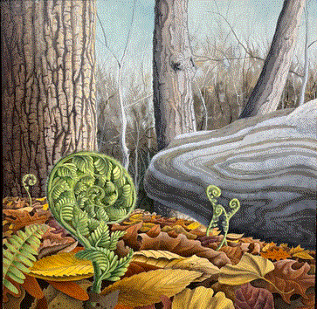 | Karl Hartman b. 9/8/1956  Unfurl, 2022  signed lower right title, year, medium, dimensions verso  oil on aluminum  12.0h x 12.0w in  30.48h x 30.48w cm  (KHA035) | $ 1,900
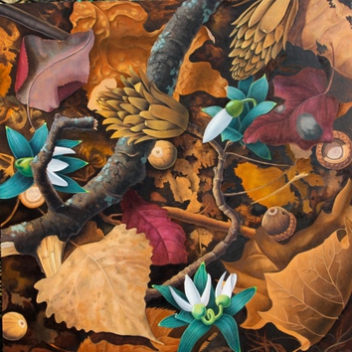 | Karl Hartman  Spring, 2024  oil on aluminum panel  12 x 12 inches  (KHA038) | $ 1,900
 | Karl Hartman b. 9/8/1956  Reflections of Ferns, 2023  signed on back  oil on aluminum  12 x 12 in.  (KHA041) | $ 1,900
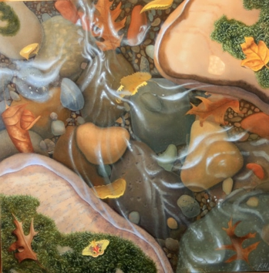 | Karl Hartman American, b. 1956  The Sound of Water, 2025  signed on back  oil on masonite  12 x 12 in.  (KHA047) | $ 1,900
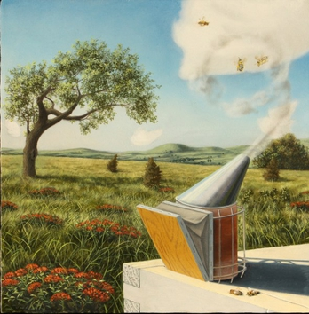 | Karl Hartman b. 9/8/1956  Bee Smoker, 2019  Oil on aluminum panel  7.0h x 7.0w in  17.78h x 17.78w cm  (KHA016) | $ 1,200
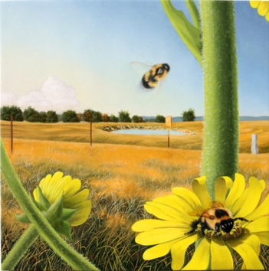 | Karl Hartman b. 9/8/1956  Bees and Pond, 2019  Oil on panel  7.0h x 7.0w in  17.78h x 17.78w cm  (KHA018) | $ 1,200

